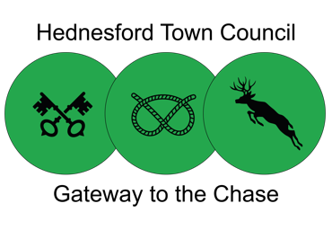
Hednesford Town Council
Community Support Grant Application Form

SECTION 1
To be completed by all applicants

CONTACT AND ORGANISATION INFORMATION

Name of organisation / group
Name of individual completing application
Position within organisation
Address and postcode of organisation
Registered address if different to above
Company number if applicable
Charity number if applicable
Company status i.e. Charity / Not for Profit / Community Interest Company / Limited / Sole Trader
If part of an affiliated / national organisation
please state
Does your group have a constitution or set of rules?
If yes please attach a copy
Does your organisation have a bank account? If yes please attach the most recent bank statement
Name of bank account signatories
Years / Months operating
Number of volunteers if applicable
Number of members if applicable
Telephone number
Email address
Website
SECTION 2
To be completed by all applicants.

ABOUT YOU
Tell us about your group / organisation

Can you give a specific example of how your group / organisation has benefited the community and residents in Hednesford?

SECTION 3
To be completed by Community Grant applicants

PROJECT
Please explain what the Community Grant will be used for.

When will the project take place? Please note that grants cannot be awarded retrospectively.

How will your project benefit the residents and community of Hednesford? Your answer will be used to help panel members make a decision on your application so please ensure you write as much as you can.

Please state why you believe this project or activity is required.

What are your group / volunteers contributing / gaining from this project?

If this is a new project and you want to carry it on in the future, how will you make sure it continues after the funding from the application has been used?

SECTION 4
To be completed by all applicants.

COSTS
How much are you applying for? Please note that the maximum amount you can be awarded is £500.00

Please tell us what you would buy with the grant money if your application was successful?

Please provide an itemised breakdown of costs and detail the item / quantity / cost.

Is the total cost of the project greater than the amount applied for? Yes No
If yes, please tell us how you plan to raise the rest of the money. Please let us know if you have applied for other funding to make up the difference.

Have you received any grants from us previously? Yes No

If yes, please state the date and amount.

Have you applied for any other grants / funding streams to support this project? Yes No

If yes, please provide details including the name of the organisation and the level of funding you received.

Please detail fundraising efforts to date to support this project / idea including any sponsorship, crowdfunding, membership fees.

Data Protection Statement
We need the information we ask for on this form to assess your grant application.

By submitting this application, you are consenting to us sharing appropriate information on this application with employees, Councillors and Grant Panel members. This information may be used for publicity purposes if the grant is awarded.

Declaration
We have read and understood the terms and criteria of the Hednesford Town Council Community Grant Scheme.

We declare that all the information given by us is true and we understand that if any funds are not used for the purpose outlined in this application, then they are liable to be recovered by Hednesford Town Council.

We will keep full records of all receipts relating to expenditure and will provide to the Council within six weeks of completing the work outlined in this application form if requested. If the group or business is dissolved and equipment has been purchased with this grant, any such equipment remaining will be distributed within the community at the discretion of Hednesford Town Council.

Signatures authorising this application from your group, organisation or business.
(two people must sign this form unless you are the sole company director).

Signature 1 Signature 1

Name (please print) Name (please print)

Date Date

Please include any supporting documents including your organisation constitution /rules or statement of your company aims/objectives, recent copy of organisation bank statement and any other supporting information that may assist your application.

Media consent form
I consent to being photographed/recorded by Hednesford Town Council and authorise that the photos / recordings may be used in the following ways:

- In publicity materials, including printed publications, promotional videos, and digital media including Hednesford Town Council website and social media

- In news releases sent to the media, including local press

Name (please print) Signature (if under 18 a guardian must sign on behalf)

Date

If you’d like us to stop using an image / recording at any time please let us know by emailing
matthew.johnson@hednesford-tc.gov.uk or calling us on tel 01543 424 872.

Under the 1998 Data Protection Act, your rights include:

- Your consent to the publication of your images can be withdrawn at any time

- Your images / recordings will not be used for any other purpose without your further consent

- The contact information you have provided will only be used to contact you about these images

Conditions of use

- We will not include personal e-mail, postal addresses or telephone numbers on video, our website or in printed publications and advertising

- We may use group or class images with very general labels such as ‘Winners of Council grants’

- We may use the image in literature unrelated to when the picture was actually taken

- We may include your full name with the image

- We will retain your consent form for five years, however we reserve the right to store and retain the images/recordings in our archive indefinitely

Return application forms

By post
Community Grant Application
Hednesford Town Council
Pye Green Community Centre
Bradbury Lane
Hednesford
WS12 4EP
By email
Community Grants - Matt Johnson, Community Officer
matthew.johnson@hednesford-tc.gov.uk

Guidance Notes and Conditions of Funding
Hednesford Town Council awards grants to local organisations and community groups to assist them in achieving their aims and objectives.

Please ensure that you read all the following prior to applying for the funding.

Funding Guidance/ Terms and Conditions:

- Funding applications can only be accepted from groups, organisations and businesses who work within Hednesford and benefit the local community

- Please ensure that all questions on the form are completed in full and provide any additional documentation as needed to support your application

- Grants are for a maximum of £500.00

- The funding is available for start-up groups and organisations as well as those already operating and established (We do require a bank account in the groups/organisations name, relevant signatories and documentation relating to the constitution of the group)

- There are some things that will not be considered, including:

- Applications from individuals
- Activities that occur outside of Hednesford
- Discrimination on the grounds of race, gender, age, disability, religion
- Buying, selling or consumption of alcohol
- Activities that support any political or religious activities
- Profit-making / fundraising activities (community grant only)

If you have concerns over eligibility for the funding please contact us.

- Statutory duties such as Education, Health or Social services for which the Central Government, Health Authority, District or County Council are the appropriate funder will not be considered; although local schools may apply for funding for items not considered statutory to their nature.

- Groups / organisations must clearly state aims and objectives and provide a written constitution or governing documents in order to be eligible to apply for the funding.

- The group/ organisation is required to have its own bank account in its own name, with two authorised signatories as named on the application form.

- The group / organisation is required to submit accounts that have been independently considered by a qualified person for the previous financial year or in the case of a new group /organisation a budget and plan.

- The Town Council has the right to reclaim the grant in the event of it not being used for the purpose noted on the application form.

- Organisations receiving grant money are required to acknowledge the Town Council’s contribution on all media/publicity work.

- All awarded organisations must complete the feedback form and have submitted it by Monday 24 April 2023.
Grant application timeline
Please note that we do not accept late entries or second applications from organisations in the same funding round.

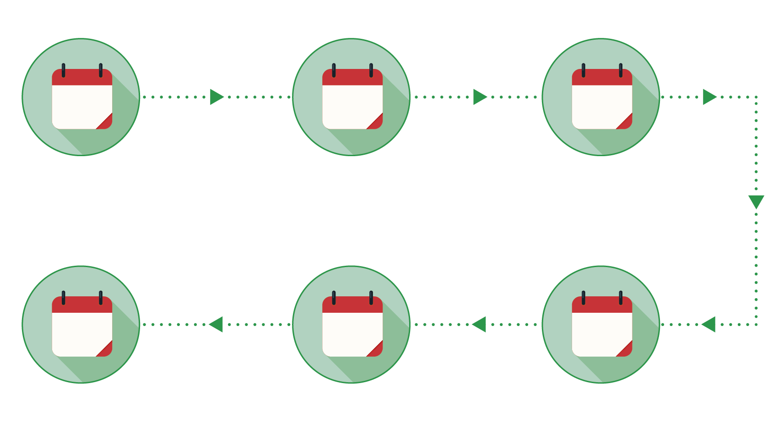
Monday 24 April 2023
Project feedback forms returned from grant awardees
Week commencing
24 October 2022
Grants awarded
Week commencing
10 October 2022
Successful applicants notified
Week commencing
26 September 2022
Panel assess applications
Monday 5
September 2022
Application deadline
Week commencing 18 July 2022
Launch Community Grants
24
2023
APR
24
2022
OCT
OCT
2022
10
SEP
2022
26
SEP
2022
5
18
2022
JUL

Further information
If you have any enquiries regarding the funding or application process, please contact Hednesford Town Council on 01543 424872.

Community Grants
Matt Johnson
Community Officer
matthew.johnson@hednesford-tc.gov.uk

Hednesford Town Council
Pye Green Community Centre
Bradbury Lane
Hednesford
WS12 4EP

THANK YOU

