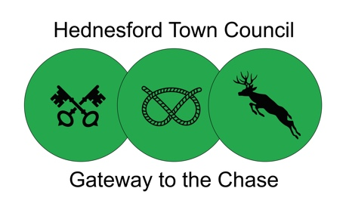
Matters Arising Form
Please complete a separate form each time a matter of concern is raised. Once completed please ensure that it passed to the Chief Officer at Hednesford Town Council to be logged, actioned, and responded to.
If you have concerns about immediate harm or danger to any person or child(ren) you MUST immediately initiate the Hednesford Town Council safeguarding procedure or in the case of an emergency always dial 999.

Name of person raising concern: |  | Date raised:
Address: (for the purpose of a response being given) |  | Contact Number:
 |  | Contact Email:

Summary of matters arising

Details of any advice, feedback already given and by who

Office Use Only
Date received by Office: |  | Name of receiving Officer:
Action taken/to be taken: (including who referred to if applicable)
Response provided to person who raised matter: |  | Date of response:
Any follow up required with details:

Date closed: |  | Officer Name:

Forms to be returned to: Hednesford Town Council Office, Pye Green Community Centre, Bradbury Lane, Hednesford, WS12 4EP or email to Admin@hednesford-tc.gov.uk. Telephone: 01543 424872. Please allow 7 working days for initial response contact from Hednesford Town Council. All information will be kept in line with Hednesford Town Councils Data Protection Policy and in line with the Data Protection Act (GDPR) 2018

