Hednesford Town Council
Community Support Grant Application Form 2025 2025


SECTION 1
To be completed by all applicants

CONTACT AND ORGANISATION INFORMATION

Name of organisation / group
Full name of individual completing application
Position within organisation
Full address and postcode of organisation
Registered address if different to above
Company number if applicable
Charity number if applicable
Company status i.e. Charity / Not for Profit / Community Interest Company
If part of an affiliated / national organisation
please state
Does your group have a constitution or set of rules?
If YES please attach a copy
Does your organisation have a bank account? If YES please attach the most recent bank statement
State name(s) of bank account signatories
Years / Months operating
Number of volunteers if applicable
Number of members if applicable
Contact Telephone number
Contact Email address
Website
SECTION 2
To be completed by all applicants.

ABOUT YOU
Tell us about your group / organisation (Max 200 words)

Please give a specific example of how your group / organisation has benefited the community and residents in Hednesford (Max 200 words)

SECTION 3
To be completed by Community Grant applicants

YOUR PROJECT
Please explain your project. (Max 200 words)

When will the project take place? Please note that grants cannot be awarded retrospectively.

How will your project benefit the residents and community of Hednesford? Your answer will be used to help panel members decide on your application

Please describe clearly why you believe this project or activity is required. (Max 200 words)

What are your group members / volunteers / gaining from this project? (Max 200 words)

If this is a new project and you aim to carry it on in the future, how will you make sure it continues after the funding from the application has been used?

SECTION 4
To be completed by all applicants.

COSTS
The maximum Grant that can be awarded is £500.00

Please state how much Grant you are applying for and clearly explain how the grant funding will be used (Max 200 words)

Please provide an itemised breakdown of project costs below and detail Item / Quantity / Cost.

Is the total cost of the project greater than the amount applied for? Yes No

If YES, please tell us how you plan to raise the rest of the money. Please let us know if you have applied for other funding to make up the difference.

Have you received any grants from us previously? Yes No

If YES please state the amount, the date of the award and a brief summary of the project.

Have you applied for any other grants / funding streams to support this project? Yes No

If YES please provide details including the name of the organisation and the level of funding you received.

Please detail below any fundraising efforts to date supporting this project including any sponsorship, crowdfunding, etc (Max 200 words)

Data Protection Statement
We need the information we ask for on this form to assess your grant application.

By submitting this application, you are consenting to us sharing appropriate information on this application with employees, Councillors and Grant Panel members. This information may be used for publicity purposes if the grant is awarded.

Media consent form

I consent to being photographed/recorded by Hednesford Town Council and authorise that the photos / recordings may be used in the following ways:

- In publicity materials, including printed publications, promotional videos, and digital media including Hednesford Town Council website and social media

- In news releases sent to the media, including local press

Name (please print) Signature

Date

If you’d like us to stop using an image / recording please let us know by emailing:
matthew.johnson@hednesford-tc.gov.uk or telephone 01543 424 872.

Under the 1998 Data Protection Act, your rights include:

- Your consent to the publication of your images can be withdrawn at any time

- Your images / recordings will not be used for any other purpose without your further consent

- The contact information you have provided will only be used to contact you about these images

Conditions of use

- We will not include personal e-mail, postal addresses or telephone numbers on video, our website or in printed publications and advertising

- We may use group or class images with very general labels such as ‘Winners of Council grants’

- We may use the image in literature unrelated to when the picture was actually taken

- We may include your full name with the image

- We will retain your consent form for five years; however we reserve the right to store and retain the images/recordings in our archive indefinitely

Return application forms

By Post or in person to:
Community Grant Application
Hednesford Town Council
Pye Green Community Centre
Bradbury Lane
Hednesford
WS12 4EP

By Email to:
Community Grants - Matt Johnson, Community Officer
matthew.johnson@hednesford-tc.gov.uk

Guidance Notes and Conditions of Funding

Hednesford Town Council awards grants to local organisations and community groups to assist them in achieving their aims and objectives.

Please ensure that you read all the following conditions prior to applying for the funding.

Funding Guidance/ Terms and Conditions:

- Funding applications can only be accepted from groups or organisations who work within Hednesford and benefit the Hednesford community

- Please ensure that all questions on the form are completed in full and provide any additional documentation as needed to support your application

- Grants are for a maximum of £500.00 and awarded and agreed by Full Council

- The funding is available for start-up groups and organisations as well as those already operating and established (We do require a bank account in the groups/organisations name, relevant signatories and documentation relating to the constitution of the group)

- There are some things that will not be considered for funding, including:

- Applications from individuals
- Activities that occur outside of Hednesford
- Discrimination on the grounds of race, gender, age, disability, religion
- Buying, selling or consumption of alcohol
- Activities that support any political or religious activities
- Profit-making / fundraising activities

- Statutory duties such as Education, Health or Social Services for which the Central Government, Health Authority, District or County Council are the appropriate funder will not be considered; although local schools may apply for funding for items not considered statutory.

- Groups / organisations must clearly state aims and objectives and provide a written constitution or governing documents in order to be eligible to apply for the funding.

- Hednesford Town Councillors and relatives of serving Town Councillors are not eligible to apply for the Grant

- Your group/ organisation is required to have its own bank account in its own name, with two authorised signatories as named on the application form.

- Your group / organisation is required to submit accounts that have been independently considered by a qualified person for the previous financial year or in the case of a new group /organisation a budget and plan.

- The Town Council has the right to reclaim the grant in the event of it not being used for the purpose as outlined on the application form.

- Organisations receiving grant money MUST acknowledge the Town Council’s contribution on all media/publicity work.

- A representative from your organisation MUST be available to attend the Annual Town Assembly on Friday 16th May 2025 if the application is successful.

- All Grant awardees MUST complete a Project Report Update at 6 months and 12 months detailing the positive impact that the grant funding has had for their organisation. This will be emailed to you by the Community Officer

Declaration
We have read, understand and agree to the terms and criteria of the Hednesford Town Council Community Grant Scheme.

We declare that all the information given by us is true and we understand that if any funds are not used for the purpose outlined in this application, then they are liable to be recovered by Hednesford Town Council.

We will keep full records of all receipts relating to expenditure and will provide to the Council within six weeks of completing the work outlined in this application form if requested. If the group or business is dissolved and equipment has been purchased with this grant, any such equipment remaining will be distributed within the community at the discretion of Hednesford Town Council.

Signatures authorising this application from your group or organisation
(Two people must sign this form unless you are the sole company director).

Signature 1 Signature 2

Name (please print) Name (please print)

Date Date

Please remember to include any supporting documents including your organisation constitution /rules or statement of your company aims/objectives, recent copy of organisation bank statement and any other supporting information that may assist your application.

Grant application timeline
Please note that we do not accept late entries or second applications from organisations in the same funding round.

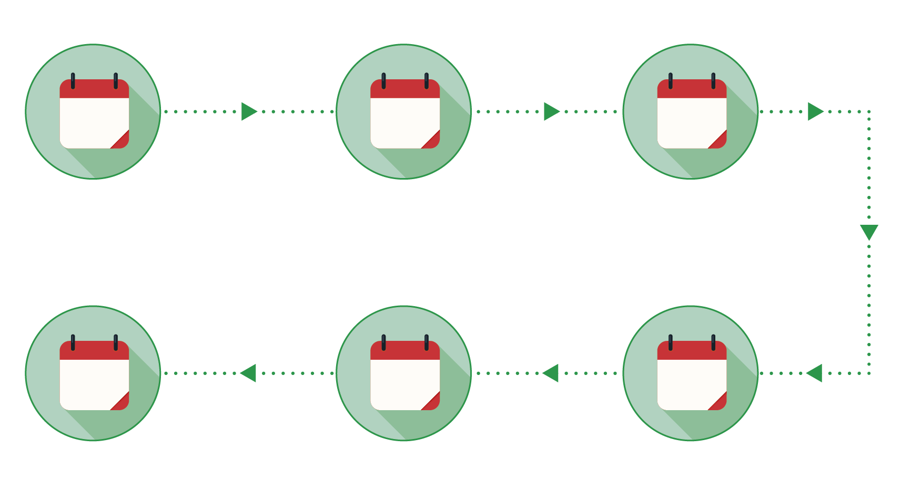
28 November 2025
6 month project update report from grant awardees – final report due May 2026
16th May 2025
Grants awarded
Week commencing
28 April 2025
Successful applicants notified
Week commencing
7 April 2025
Panel assess applications
30 March 2025
Application deadline 8am
Week commencing 20 January 2025
Launch Community Grants
28
2025
Nov
16
2025
May
Apr
2025
28
Apr
2025
7
Mar
2025
30
20
2025
Jan

Further information

If you have any enquiries regarding the funding or application process, please contact Hednesford Town Council on 01543 424872 or visit www.hednesford-tc.gov.uk – projects and community - funding

Community Grants

Matt Johnson
Community Officer
matthew.johnson@hednesford-tc.gov.uk

Hednesford Town Council
Pye Green Community Centre
Bradbury Lane
Hednesford
WS12 4EP

